ALC Liberal Arts

Unit 5

1. A triangle with one right angle

a. right angle

b. right triangle

c. side

d. triangle

2. The edge of a polygon

a. right angle

b. right triangle

c. side

d. triangle

3. The longest side of a right triangle; the side opposite the right angle

a. hypotenuse

b. leg

c. order of operations

d. Pythagorean theorem

4. The square of the hypotenuse (c) of a right triangle is equal to the sum of the squares of the legs (a and *b*), as shown in the equation c2 = a2 +b2

a. hypotenuse

b. leg

c. order of operations

d. Pythagorean theorem

5. A polygon with three sides; the sum of the measures of the angles is 180°

a. right angle

b. quadrilateral

c. side

d. triangle

6. In a right triangle, one of the two sides that form the right angle

a. hypotenuse

b. leg

c. order of operations

d. Pythagorean theorem

7. A __________ is a polygon with four sides and four right angles.

a. perimeter

b. Pythagorean theorem

c. rectangle

d. right triangle

8. The distance around a polygon is called the _______________.

a. perimeter

b. Pythagorean theorem

c. rectangle

d. right triangle

9. A ____________ is a line segment that connects two vertices of a polygon but is not a side of the polygon.

a. diagonal

b. hypotenuse

c. leg

d. perimeter

10. A triangle with three congruent sides is a/an __________ triangle

a. square

b. equilateral triangle

c. rectangle

d. right triangle

11. A triangle with two sides the same length is a/an ___________ triangle.

a. square

b. right triangle

c. rectangle

d. isosceles triangle

12. A right triangle whose hypotenuse is twice the short leg and whose long leg is $\sqrt{3}$ times the short leg is called a ____________ triangle.

a. 30°-60°-90°

b. 45°-45°-90°

c. side

d. special

13. An angle whose measure is exactly 90°

a. right angle

b. quadrilateral

c. side

d. triangle

14. Another name for an isosceles right triangle is a _________________triangle.

a. 30°-60°-90°

b. 45°-45°-90°

c. side

d. special

15. Find the length of the missing side

a. x = 28

b. x = 10

c. x = 100

d. x = 86

16. Find the length of the missing side

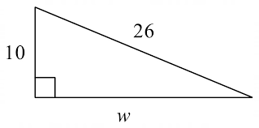

a. w = 36

b. w = 16

c. w = 14

d. w = 24

17. Find the length of the missing side

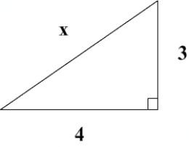

a. x = 6

b. x = 8

c. x = 5

d. x = 7

18. Adele takes a sheet of paper and cuts from one corner to the opposite corner, making two triangles. If the piece of paper is 3 inches long and 4 inches wide, how long is the diagonal cut that Adele made?

a. 5 inches

b. 2 inches

c. 7 inches

d. 9 inches

19. A mouse has made holes in opposite corners of a rectangular kitchen. The width of the kitchen is 9 feet and the distance between the mouse's holes is 15 feet. What is the length of the kitchen?

a. 15 feet

b. 17 feet

c. 12 feet

d. 22 feet

20. The diagonal of a rectangle is 15 meters. The length of a side is 9 meters. Find the perimeter of the rectangle.

a. 15 meters

b. 48 meters

c. 12 meters

d. 42 meters