ALC Liberal Arts Math

Unit 9

1. The distance around a circle.

a. diameter

b. radius

c. surface area

d. circumference

2. A line segment extending from the center of a circle or sphere to a point in the circle of sphere.

a. circumference

b. diameter

c. radius

d. lateral area

3. The amount of space occupied in three dimensions and expresses in cubic units.

a. surface area

b. volume

c. lateral area

d. base area

4. The sum of the areas of the faces and any curved surfaces of the figure that create the geometric solid.

a. surface area

b. volume

c. lateral area

d. base area

5. The area of the sides of a geometric solid.

a. surface area

b. volume

c. lateral area

d. base area

6. Calculate the volume of a cube with a side length of 2 inches.

a. 18 inches3

b. 8 inches3

c. 6 inches3

d. 10 inches3

7. If the length, width, and height of a cuboid are 5 cm, 3 cm, and 4 cm, what is its volume?

a. 60 cm3

b. 12 cm3

c. 64 cm3

d. 32 cm3

8. If the length of the side of the cube is 6 cm, what is the total surface area?

a. 18 cm2

b. 216 cm2

c. 206 cm2

d. 36 cm2

9. If the length, width, and height of a cuboid are 5 cm, 3 cm, and 4 cm, then what is the lateral surface area?

a. 12 cm2

b. 23 cm2

c. 32 cm2

d. 64 cm2

10. Find the totalsurface area of a cylinder of radius 5 cm and height 8 cm.

a. 605.8 cm2

b. 620.8 cm2

c. 615.8 cm2

d. 635.8 cm2

11. Find the total surface area of a regular pyramid with a square base if each edge of the base measures 16 inches, the slant height of a side is 17 inches, and the altitude is 15 inches.

a. 800 inches2

b. 287 inches2

c. 674 inches2

d. 856 inches2

12. Find the lateral surface area of a cylinder with a base radius of 3 inches and a height of 9 inches.

a. 169.64 inches2

b. 189.46 inches2

c. 176.84 inches2

d. 219.36 inches2

13. Find the total surface area of a cylinder with a base radius of 5 inches and a height of 7 inches.

a. 326.89 inches2

b. 456.79 inches2

c. 476.99 inches2

d. 376.99 inches2

14. Find the lateral surface area of a regular pyramid with a triangular base if each edge of the base measures 8 inches and the slant height is 5 inches.

a. 50 inches2

b. 60 inches2

c. 80 inches2

d. 70 inches2

15. calculate the side length of a cube whose volume is 64 in3

a. 4 in

b. 6 in

c. 8 in

d. 2 in

16. Calculate the volume of the figure below

a. 18 cm3

b. 14 cm3

c. 84 cm3

d. 90 cm3

17. Calculate the lateral area of the figure below

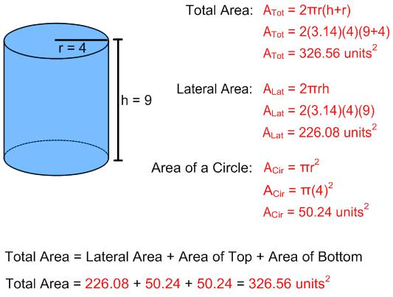

a. 226.08

b. 336.80

c. 196.08

d. 206.08

18. Calculate the total surface area of the figure below

a. 326.08

b. 336.80

c. 396.08

d. 326.56

19. Calculate the lateral area of the figure below

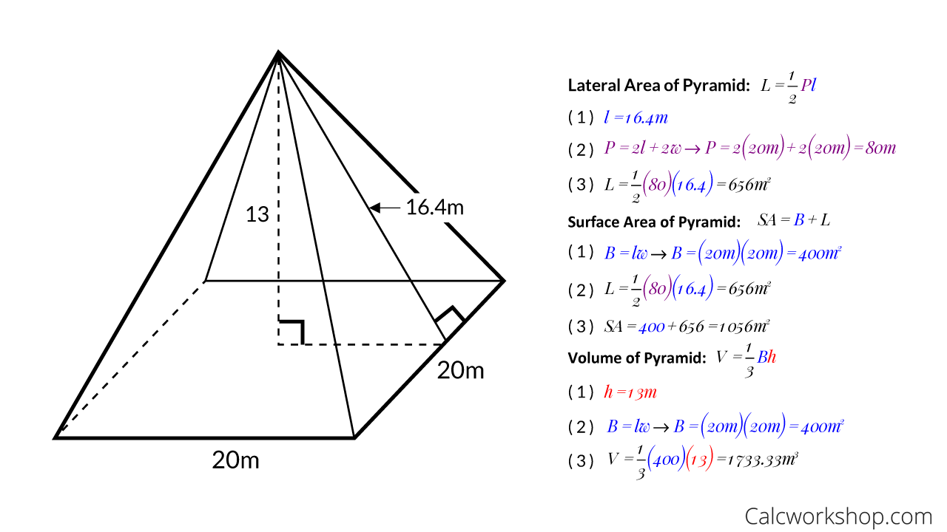

a. 676 m2

b. 636 m2

c. 656 m2

d. 696 m2

20. Calculate the total surface area of the figure below



a. 1156 m2

b. 1056 m2

c. 1126 m2

d. 1006 m2